Agile Pune 2025 – Vibe Coding Workshop
D.Y. Patil Engineering College, Pune | In‑person | Audience: ~200 students| 15-Nov-2025

Contents
Final Session Title 2
Vibe Mode: On! For Vision-Innovation-Build-Engineering 2
Updated Session Overview 2
Prerequisites 3
Firebase-Studio 4
Agri Direct 4
Prompt : 6
App Blueprint 6
Where can I find the API KEY ? Please provide steps for making the above changes. 7

Final Session Title

Vibe Mode: On! For Vision-Innovation-Build-Engineering

Updated Session Overview
This high‑energy, hands‑on workshop introduces participants on ways for leveraging Vibe Coding for building software by combining human creativity with AI Agents. Using Vibe coding platforms like Google AI Studio, Firebase, and GitHub Copilot, participants will prototype a working app, practice prompt engineering, and experience pair/XP-style collaboration with AI Agents to boost quality and speed. Participants will experience how Vibe coding with GenAI changes ideation, design, coding, testing, and documentation, plus ways to avoid hallucinations while ensuring secure, responsible use. Join us to learn, build, and ship your products faster while discovering how GenAI opens new opportunities in modern software engineering.
🔑 Key Takeaways
- Live GenAI App Prototyping
Hands-on experience building a multi-modal apps using Vibe coding platforms like GitHub Copilot, Google AI Studio or Google Firebase Studio.
- Vibe Coding and Agentic Collaboration
Learn how to co-create with AI Agents with XP-style collaboration and Agentic capabilities to boost speed, creativity, and code quality.
- Vibe coding and Prompt Engineering Mastery
Practice writing effective prompts for ideation, design, coding, testing, and documentation.
- Responsible GenAI Use
Gain a mental model for secure, ethical, and environmentally conscious GenAI development—avoiding hallucinations and misuse.
- Internship & Career Readiness
Map GenAI skills to real-world roles, showcasing how vibe coding accelerates onboarding and productivity in entry-level tech jobs.

Prerequisites
- Laptop with Chrome/Edge, stable internet
- GitHub account (Copilot access/Free trial)
- Google account for AI Studio and Firebase
- VS Code installed (latest)
- No coding experience required but basic knowledge of Software Engineering, One Programming Language with help.
- Willingness to build career in Technology steams, adopt and embrace the pair‑programming with AI Agents and learn by doing

Firebase-Studio

- Open Firebase Studio
- Login with your google account.

We will Vibe code a new application.

Agri Direct

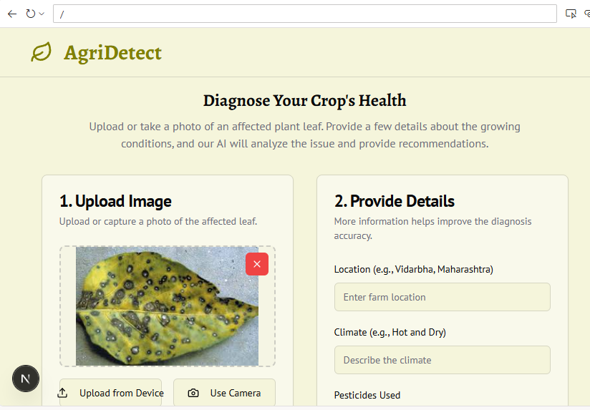

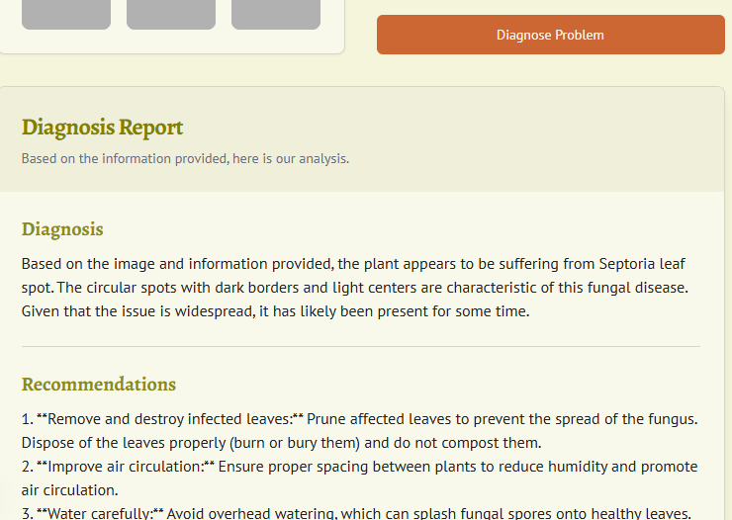

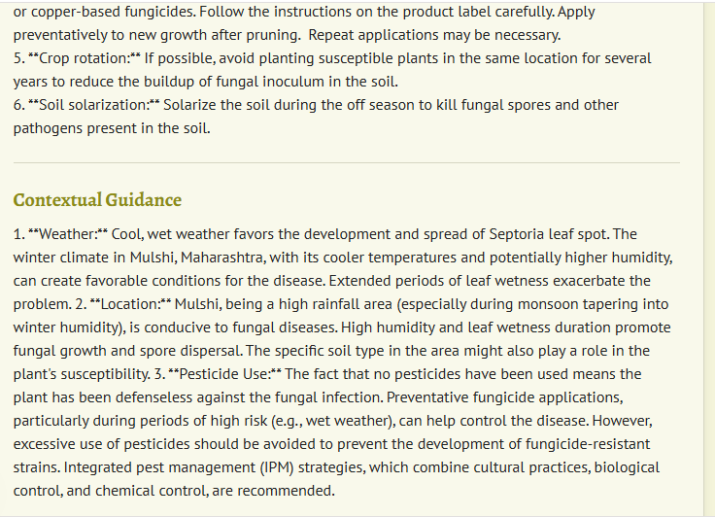

Prompt :

- We want to build a prototype for farmer to diagnose the infection on his crop. A farmer in Vidarbha sees a strange pattern on his cotton leaves. He will be taking the photo of the leaves and upload to app. The farmer can take the photo of the image using his phone as well. There will be a button to "diagnose" the problem. The farmer can provide more details in text like location, climate, pesticide used etc. The AI will then "analyze" the input (a simple, pre-programmed response for the demo) and give a diagnosis and a recommendation. This simulates the AI's role in empowering the farmer. We can give 2-3 sample images in the application to show the demo of AI based diagnosis. In the analysis report we can provide some guidance on how the weather, location and use of pesticides play a role in the issues. Help to build this prototype. Sample image of plat disease is attached

OK, here's a plan for how we'll prototype this app. Take a look below and customize as needed, or if you're ready, select Prototype this App.

App Blueprint
- Image Upload — Upload an image of the affected crop leaf for diagnosis.
- Camera Capture — Capture image using camera for diagnosis.
- Additional Details Input — Input additional details such as location, climate, and pesticides used.

AI Diagnosis — Diagnose the plant disease using the uploaded image and provided details; use of tool is necessary.

- Diagnosis Report Display — Display the diagnosis and recommendations to the farmer in a clear report.
- Sample Images — Include sample images for demonstration.
- Contextual Guidance — Explain the influence of weather, location, and pesticide usage on the diagnosis.

- Color
- TypographyFont pairing: 'PT Sans' (sans-serif) for body text and 'Alegreya' (serif) for headlines, blending readability with elegance.
- AI
- Gemini, Genkit
  - UI
- TypeScript, NextJS, Tailwind CSS

Prompt - Prototype this App
OK, let's prototype this app!

- It appears that your app needs a Gemini API key!

Questions:

- When the external user is accessing the published application , the application fails when the user clicks on the diagnose button. It looks like the call that uses the Gemini LLM API key fails for external users. The same call and application works perfectly fine when used from the project workspace. What could be the reason and how can this be fixed?

- It sounds like the Gemini API key isn't available in your production environment. This is a common issue when moving from a local development workspace to a live application. When you run the app locally, it can access API keys from your local .env file, but these are not automatically available when the app is deployed.
- To fix this, I will modify src/ai/genkit.ts to explicitly load environment variables. This will ensure that your Gemini API key is available to the application when it's running in production.

Where can I find the API KEY ? Please provide steps for making the above changes.

- Of course. I can guide you through that. You'll need to get your API key from Google AI Studio and then add it as a secret to your Firebase project.

- Here are the steps:
- Go to Google AI Studio: Open your web browser and navigate to https://makersuite.google.com/.
- Generate API Key:
  - Click on the "Get API key" option, usually located in the left-hand menu.
  - You will be prompted to create an API key within a Google Cloud project. You can either use an existing project or create a new one.
- Copy Your Key: Once the key is created, copy it to your clipboard. Keep this key safe and do not share it publicly.
- Open Firebase Console: Go to the Firebase Console and select your project.
- Navigate to App Hosting: In the left-hand menu under the "Build" section, click on "App Hosting".
- Select Your Backend: You should see your App Hosting backend listed. Click on it to open its dashboard.
- Add the Secret:
  - Go to the Settings tab.
  - Find the Secrets section.
  - Click on "Add secret".
  - For the Secret name, enter GEMINI_API_KEY.
  - In the Secret value field, paste the API key you copied from Google AI Studio.
  - Click "Save".
- After you've added the secret, your deployed application will have secure access to the Gemini API, and the error should be resolved. The code I added in the previous step is already set up to read this secret.

